## horizontal line



Capstone Design Update: Y-Axis Control

Robotic Air Hockey System  
2018.07.23

Thomas Abdallah - 7141518

Conestoga College

Electronic Systems Engineering  
Capstone Project II - EECE74135

Semester 8, Class of 2018

# Introduction

This document will cover the design changes made to the Y-Axis mechanism and control strategy since the submission of the formal design document.

# Motivation

The initial design of the Y-Axis mechanism included two independent belt-driven linear actuators, one for each side of the air hockey table (Figure 1).

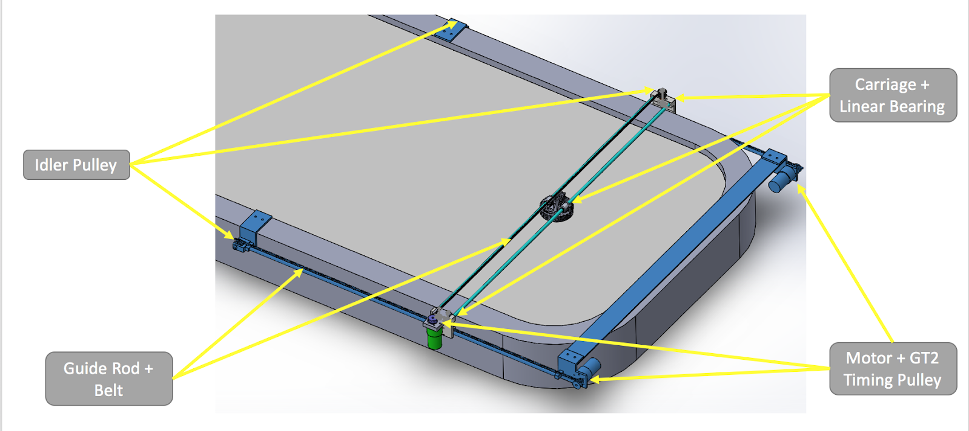

Figure – Low Speed Prototype Design

The low-speed prototype built in Semester 7 successfully implemented this mechanism, although there were challenges controlling the independent actuators such that their positions were closely matched at all times. A master-slave control strategy was implemented that was able to keep the left and right actuator positions matched to within +/- 10mm (Figure 2). The master-slave controller treated the left actuator as the master and calculated torque commands based on the error between the actuators commanded position and its actual position. The right motor (slave) was controlled in the same way as the master unless its actual position deviated by more than 10mm from the masters’ position. If the relative position error was larger than 10mm the slave would be controlled based on how far its position deviated from the masters’ position. In this way both actuators were kept synchronized while moving to the Y-Axis’ commanded position.

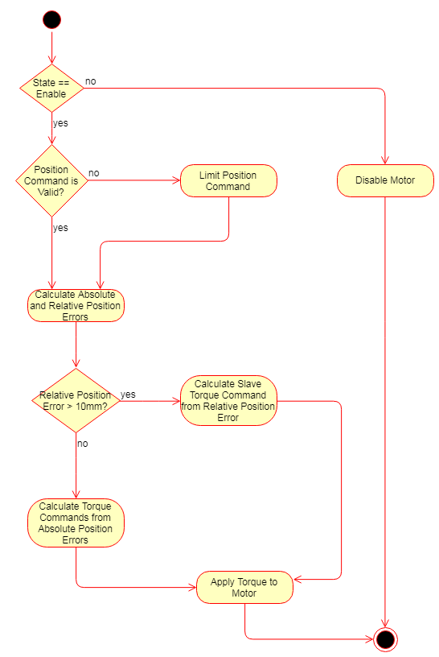

Figure - Master-Slave Motor Controller

The high-speed prototype built in Semester 8 featured the same mechanism with two independent actuators and was able to achieve similar performance at low-speeds using the master-slave control strategy. When speeds were increased the master-slave controller was unable to keep the left and right actuators synchronized and stable.

# Design Change Prototyping

Several alternative control strategies were considered and prototyped in an attempt to keep the left and right actuators synchronized at high speeds. The most promising solution was one where the controller gains for the left and right actuators were dynamically changed based on the relative position error between the two actuators. This controller was able to stably control the Y-Axis at moderate speeds, but not fast enough to achieve our design goals.

After several days of prototyping software based solutions, a mechanical solution was designed and prototyped. The mechanical solution physically links the left and right actuators together, effectively creating one large actuator powered by two motors. The left and right actuators are linked together by replacing the idler pulleys with timing pulleys on a shared rod that spans the width of the table (Figure 3). A simple controller was implemented to control the position of the Y-Axis based on absolute position error.

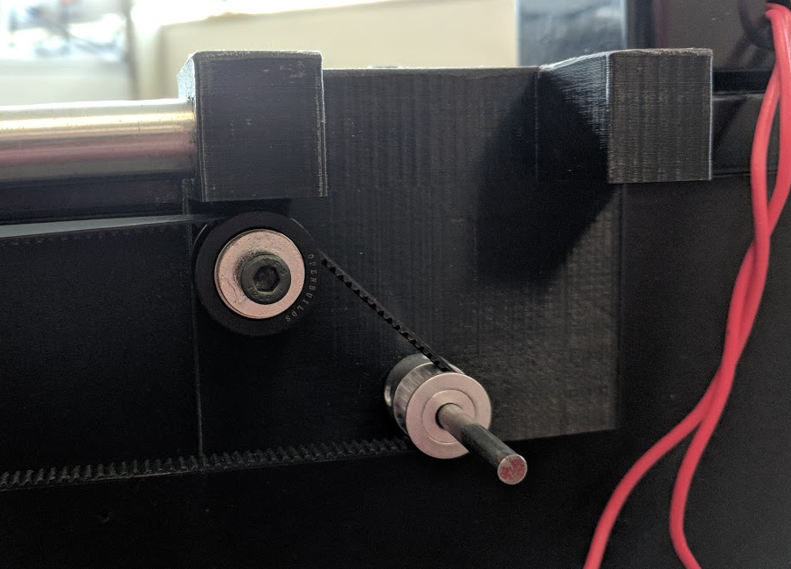

Figure - Timing Pulley and Rod Connecting Right Actuator to Left Actuator

# Design Optimization and Results

The mechanical link between the left and right actuator was refined with ball bearings to allow for free rotation of the rod and updated mounting brackets for the Y-Axis. To eliminate overshoot at high speeds and prevent the robot from hitting the hard travel limits a new “end-stop” controller was developed that sits on-top of the existing absolute position controller (Figure 4). This “end-stop” controller ensures the robot slows down gracefully if it is travelling toward a hard travel limit at high speed. This new controller was also applied to the X-Axis actuator.

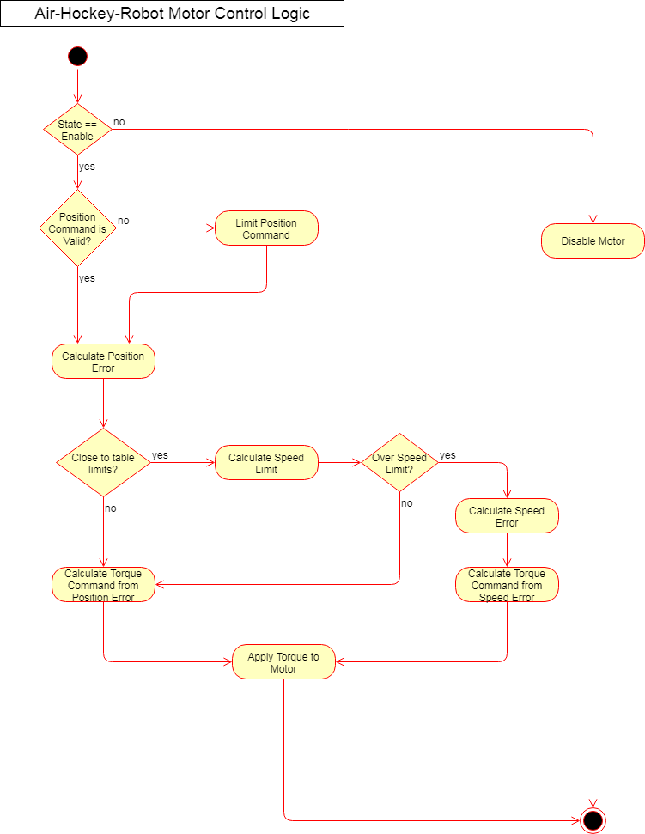

Figure - Actuator Control with End-Stop Controller

The updated design has demonstrated the ability to control the Y-Axis at speeds up to 1.8 m/s and the X-Axis at speeds up to 3.6 m/s. At these speeds the air-hockey-robot can achieve the design goal of playing air-hockey competitively against a human player.